TuneTudo
Name: Neel Patel
Email: neelp27@umd.edu
UMD Directory ID: neelp27
1. Application Overview 2
2. System Architecture 3
2.1 Components 3
2.2 How components connect 3
2.3 Important data flows 3
2.4 System Architecture Diagrams 4
3. Application Software Components 6
3.1 Classes / ORM models 6
3.2 Core Business Logic Components (services) 7
3.3 Controllers / API endpoints 8
4. Application UI Components 10
4.1 Pages / Screens 10
4.2 Navigation flow 11
5. Application Data Components 12
5.1 Storage choices 12
5.2 Database tables — CREATE TABLE examples (SQLite) 12
5.3 Indexing & search 15
5.4 How data relates to each other 16
6. Test Cases 17
7. Traceability Matrix 23
8. Security Architecture Overview 25
Input Validation 25
Authentication & Authorization 25
Data Protection 26
Security Controls 26
9. Logging Design 28
Log Format 28
Log Storage 29
10. Security Components 30
Component Architecture 30
Sub-Components 31
11. Updated Traceability Matrix 32
12. References 35

1. Application Overview
TuneTudo is a web-based music streaming app that allows users to search for songs, artists, and albums, create playlists, manage playlist and upload tracks to their personal library. The app also allows the admin to manage the catalog, upload new songs and update the metadata. The user and admin can manage their profile as well. The focus is on simplicity and core music playback features without advanced functionality like recommendations [1].
Technology Stack:
- Programming Language: Go
- Framework: Go Fiber v2 (web framework)
- Template Engine: Fiber HTML template engine
- Database: SQLite (lightweight, file-based DB)
- Frontend: Basic React SPA UI
- Architecture Style: MVC (Model-View-Controller) Architecture Approach.

2. System Architecture

2.1 Components
- Client (Web Browser) — For web page development I will use React SPA UI. The audio will be played via HTML5 and it will interact with other components via REST API.
- API Gateway / Reverse Proxy — Nginx for TLS termination, caching, static assets and load balancing.
- Web Application Backend — GO Fiber v2 framework will be used to design the backend components. REST APIs will be implemented to auth, manage playlists, search a song/album, upload a file and admin management.
- Media/Playback Service — A backend microservice that streams audio.
- Search Service — SQLite FTS for full-text search; optional separate search microservice like Trie data structure to do efficient searching if scaling is required.
- Database — SQLite for structured metadata storage.
- File Storage — Local file system (media/ images) to store the MP4 or WAV files.
- Admin Portal — Separate React route and admin-only API endpoints.
- Logging & Monitoring — App logs, metrics, and Audit logs for admin actions.
- Authentication & Session Management — JSON Web Tokens or Server sessions (secure cookies) with password reset flow will be used for authentication [2].

2.2 How components connect
Web-browser ↔ HTTPS ↔ Nginx (API Gateway) ↔ Web App Backend ↔ SQLite (metadata)
↕
File Storage (media/images)

2.3 Important data flows
- Search: Browser → GET /api/search?q= → Backend.SearchService → SQLite FTS → results → Browser.
- Play: Browser → GET /api/songs/{id}/stream → Backend.PlaybackService validates → streams from storage.
- Create Playlist: Browser → POST /api/playlists/{name} (auth) → Backend.PlaylistService → DB insert → return playlist.
- Upload User Track: Browser → POST /api/upload/{file_name} → validate format & size → store to /media/uploads/{user}/{uuid}.mp4 → create Upload record, update Song record for user [3].

2.4 System Architecture Diagrams
User Interaction with Application:
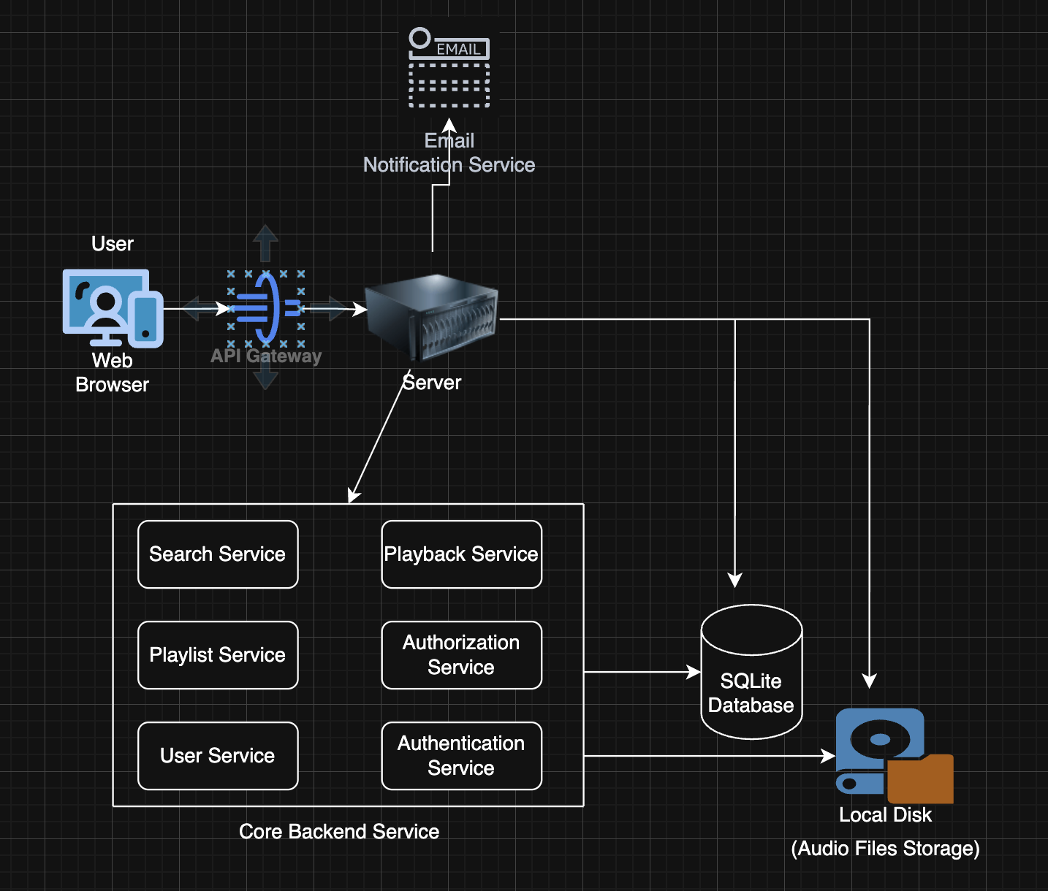
Admin Interaction with Application:
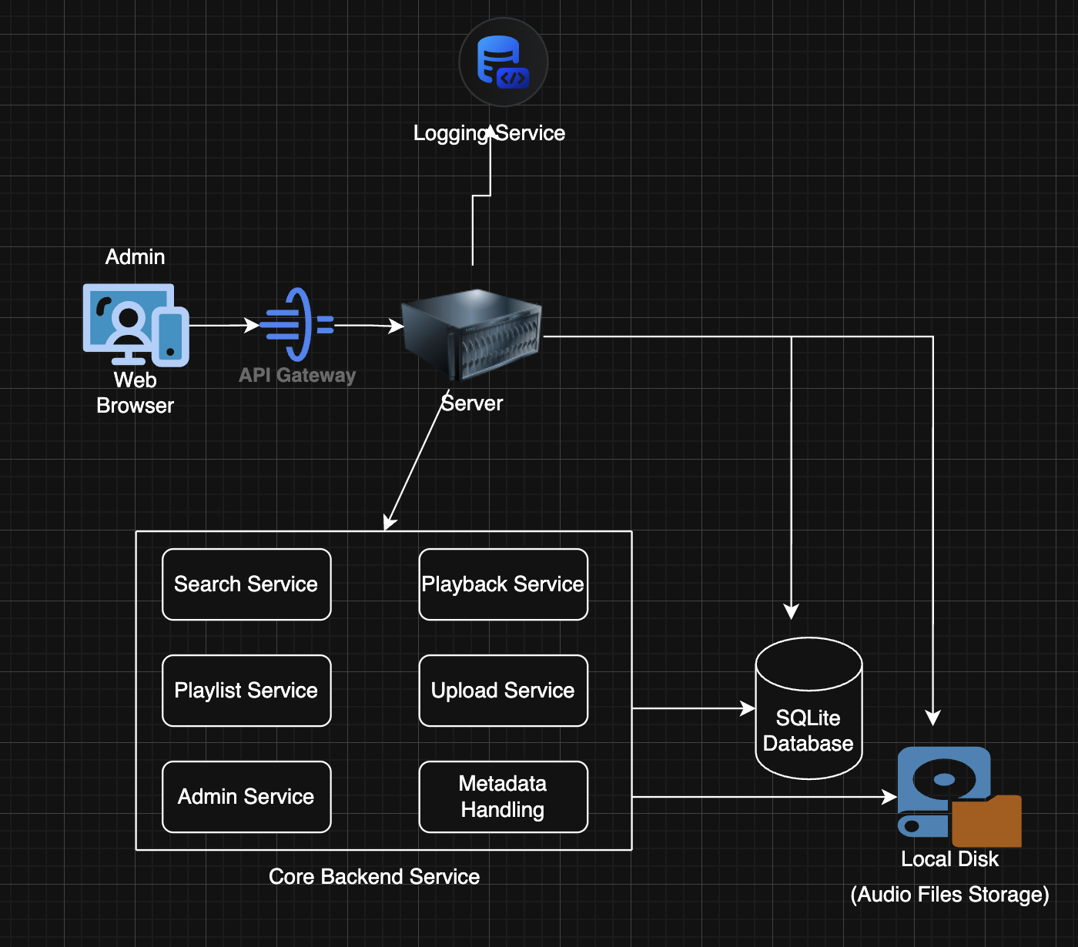

3. Application Software Components

3.1 Classes / ORM models
User
- id: int (PK)
- username: str (unique)
- email: str (unique)
- password_hash: str
- is_admin: bool
- profile_image_path: str | null
- created_at: datetime
- last_login: datetime
Artist
- id: int(PK)
- name: str
- description: text
- created_at: datetime
Album
- id: int(PK)
- title: str
- artist_id: (FK) Artist.id
- cover_image_path: str | null
- release_date: date | null
Song
- id: int(PK)
- title: str
- artist_id: (FK) Artist.id
- album_id: (FK) Album.id
- category_id: (FK) Category.id
- duration_seconds: int
- file_path: str (storage path)
- format: str (MP4/WAV)
- uploaded_by_user_id: (FK) User.id (for personal uploads) | null (if uploaded by admin)
- created_at: datetime
Category (Genre)
- id: int
- name: str
- description: text
Playlist
- id: int
- user_id: (FK) User.id
- name: str
- description: text | null
- created_at: datetime
PlaylistSong
- id: int
- playlist_id: (FK)Playlist.id
- song_id: (FK) Song.id
- queue_number: int
- added_at: datetime
Upload (for user uploads)
- id: int
- user_id: (FK) User.id
- original_filename: str
- stored_path: str
- file_size_bytes: int
- error_message: text | null
- created_at: datetime

3.2 Core Business Logic Components (services)
Some of the methods that the services will have are listed under each logic component.
- AuthorizationService
  - register_user(), login_user_or_admin(), logout_user(), reset_password_request(), reset_password().
  - Password policy check.
  - Issue JWT or session cookie.
  - Maps to FR-009, FR-010, FR-014, FR-012.
- SearchService
  - full_text_search(query), category_search(query).
  - Maintains FTS indexes or queries SQLite FTS.
  - Maps to FR-001, FR-005.
- PlaylistService
  - create_playlist(user_id, session_token), delete_playlist(id), add_song(playlistId, songId), remove_song(playlistId, songId).
  - Maps to FR-002, FR-003, FR-006, FR-007.
- PlaybackService
  - authorize_stream(user, songId), stream_handler().
  - Maps to FR-004.
- AdminService
  - upload_song(metadata, file), bulk_import_csv(json)
  - admin-only functionalities.
  - Maps to FR-012, FR-013.
- UserService
  - upload_profile_image(user, file), get_profile(userId), upload_song(file)
  - Maps to FR-011.
- NotificationService
  - send_email_password_reset().
  - Maps to FR-009 (password reset flows).
- AuditService
  - log_admin_action(), log_events().

3.3 Controllers / API endpoints
Auth APIs
- POST /api/auth/register → AuthService.register_user (FR-009)
- POST /api/auth/login → AuthService.login_user (FR-010)
- POST /api/auth/logout → AuthService.logout_user (FR-014)
- POST /api/auth/password-reset → AuthService.reset_password (FR-010)
Search APIs
- GET /api/search?q= → SearchService.full_text_search (FR-001)
Homepage Category Display APIs
- GET /api/categories → list categories (FR-005)
- GET /api/songs/{id} → metadata
Play Song APIs
- GET /api/songs/{id}/stream → PlaybackService.stream_handler (FR-004)
Playlist APIs
- POST /api/playlists/{name} → PlaylistService.create_playlist (FR-002)
- POST /api/playlists/{id}/songs →PlaylistService.add_song (FR-003)
- DELETE /api/playlists/{id}/songs/{songId} → PlaylistService.remove_song (FR-006)
- DELETE /api/playlists/{id} → PlaylistService.delete_playlist (FR-007)
User APIs
- POST /api/upload/{file_name} → UserService.upload_song (FR-008)(For personal library)
- PUT /api/users/{id}/profile-picture → UserService.upload_profile_image (FR-011)
Admin APIs
- POST /api/admin/songs → AdminService.upload_song (FR-013) [3]

4. Application UI Components

4.1 Pages / Screens
- Home
  - Top: Search bar (global)
  - Category carousel / genre tiles (FR-005)
  - Featured playlists
- Search Results
  - Tabs: Songs | Artists | Albums | Playlists
  - Action buttons: Play, Add to playlist (FR-001)
- Song Details
  - Metadata, play controls, add to playlist, artist/album links (FR-004)
- Playlists
  - List of playlists, Create playlist button (FR-002)
  - Playlist card: name, number of songs, delete
- Playlist Details
  - Songs listed with controls: play, remove (FR-003, FR-006)
- Upload Page / Modal
  - Upload input, allowed formats, size limit (FR-008)
- Login / Signup
  - Signup fields, password policy guidance (FR-009, FR-010)
- Profile
  - Upload profile picture (FR-011)
  - Show personal library (user uploads)
- Admin Portal
  - Admin login (FR-012)
  - Upload new songs, bulk import, song list, user management (FR-013)
- 404 / Error pages

4.2 Navigation flow
- Top nav: Home | Playlists | Profile | Admin (if admin)
- Common flows:
  - Home → click Category → Category page (FR-005)
  - Home → Search → Search results → click song → plays (FR-001, FR-004)
  - Playlists → Create → Enter name → OK (FR-002)
  - Playlists → Select Playlist → Playlist Detail → Add/remove songs (FR-003, FR-006)
  - Profile → Upload → select file → validate and save (FR-008)

5. Application Data Components

5.1 Storage choices
- SQLite database for metadata (fits requirement).
- File system (media/ images) with a structure like:
  - /storage/media/songs/{song_id}/{filename}
  - /storage/media/uploads/{user_id}/{uuid}.{extension}
  - /storage/images/profiles/{user_id}/{filename}
  - /storage/images/cover/{album_id}/{filename}

5.2 Database tables — CREATE TABLE examples (SQLite)
CREATE TABLE users (
id INTEGER PRIMARY KEY AUTOINCREMENT,
username TEXT UNIQUE NOT NULL,
email TEXT UNIQUE NOT NULL,
password_hash TEXT NOT NULL,
is_admin INTEGER DEFAULT 0,
profile_image_path TEXT,
created_at DATETIME DEFAULT CURRENT_TIMESTAMP,
last_login DATETIME
);

CREATE TABLE artists (
id INTEGER PRIMARY KEY AUTOINCREMENT,
name TEXT NOT NULL,
description TEXT,
created_at DATETIME DEFAULT CURRENT_TIMESTAMP
);

CREATE TABLE albums (
id INTEGER PRIMARY KEY AUTOINCREMENT,
title TEXT NOT NULL,
artist_id INTEGER,
cover_image_path TEXT,
release_date DATE,
FOREIGN KEY(artist_id) REFERENCES artists(id)
);

CREATE TABLE categories (
id INTEGER PRIMARY KEY AUTOINCREMENT,
name TEXT NOT NULL UNIQUE,
description TEXT
);

CREATE TABLE songs (
id INTEGER PRIMARY KEY AUTOINCREMENT,
title TEXT NOT NULL,
artist_id INTEGER,
album_id INTEGER,
category_id INTEGER,
duration_seconds INTEGER,
file_path TEXT NOT NULL,
format TEXT NOT NULL,
uploaded_by_user_id INTEGER,
created_at DATETIME DEFAULT CURRENT_TIMESTAMP,
FOREIGN KEY(artist_id) REFERENCES artists(id),
FOREIGN KEY(album_id) REFERENCES albums(id),
FOREIGN KEY(category_id) REFERENCES categories(id),
FOREIGN KEY(uploaded_by_user_id) REFERENCES users(id)
);

CREATE TABLE playlists (
id INTEGER PRIMARY KEY AUTOINCREMENT,
user_id INTEGER NOT NULL,
name TEXT NOT NULL,
description TEXT,
created_at DATETIME DEFAULT CURRENT_TIMESTAMP,
UNIQUE(user_id, name),
FOREIGN KEY(user_id) REFERENCES users(id)
);

CREATE TABLE playlist_songs (
id INTEGER PRIMARY KEY AUTOINCREMENT,
playlist_id INTEGER NOT NULL,
song_id INTEGER NOT NULL,
queue_number INTEGER DEFAULT 0,
added_at DATETIME DEFAULT CURRENT_TIMESTAMP,
FOREIGN KEY(playlist_id) REFERENCES playlists(id),
FOREIGN KEY(song_id) REFERENCES songs(id),
UNIQUE(playlist_id, song_id)
);

CREATE TABLE uploads (
id INTEGER PRIMARY KEY AUTOINCREMENT,
user_id INTEGER NOT NULL,
original_filename TEXT,
stored_path TEXT,
file_size_bytes INTEGER,
error_message TEXT,
created_at DATETIME DEFAULT CURRENT_TIMESTAMP,
FOREIGN KEY(user_id) REFERENCES users(id)
);

5.3 Indexing & search
- Use SQLite FTS5 on songs (title, artist_name, album_title) for fast search.

5.4 How data relates to each other
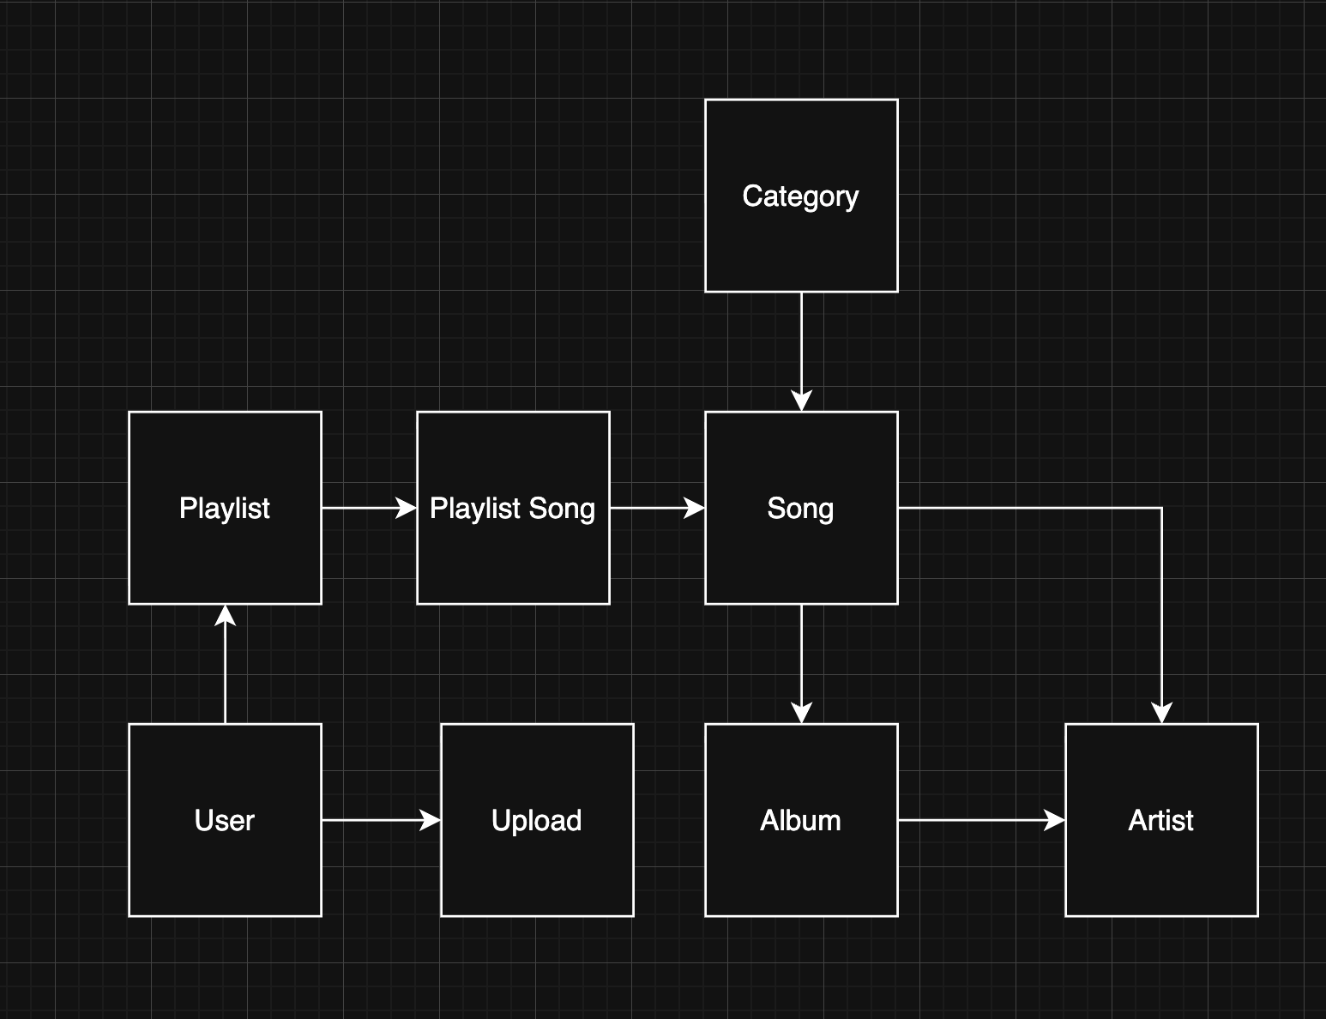
The databases will interact/relate with each other as shown in the above figure.

6. Test Cases
For each FR: I have provided test id, preconditions, steps, expected result, success criteria. These are fit for manual testing and can be adapted to automated tests (unit tests).
FR-001: Search for an Artist, Album, or Song
Test ID: T-001
Preconditions: DB has songs, artists, albums. User on homepage.
Steps:
- Enter the exact song name “Yellow” in the search bar, press Enter.
- Enter partial “Yel” and search.
- Paste text in the search field and press search.
- Search “jisdenvouenvoew”.
Expected Results for three searches respectively:
- Exact and partial return relevant rows (song item appears with play & add options).
- Partial returns best matches.
- Pasted text’s best match results.
- No results shows “No results found”.
Success criteria:
- Search returns hits in ≤1 second for sample DB size (small).
- Fuzzy/partial matches included.
FR-002: Create a New Playlist
Test ID: T-002
Preconditions: User logged in and user is in Playlists page.
Steps:
- Click “Create Playlist”.
- Enter name Focus Mix.
- Submit.
Expected:
- New playlist created, confirmation shown, appears in list.
- Creating a playlist with the same name triggers “Playlist already exists”.
- Empty name triggers “Enter Valid Playlist Name”.
Success:
- Playlist row exists in DB with corresponding user_id.
FR-003: Add a Song to an Existing Playlist
Test ID: T-003
Preconditions: At least one playlist exists.
Steps:
- From the song list, click “Add to Playlist” for a song.
- Choose Playlist “Adventure”.
Expected:
- playlist_songs row created in database and confirmation message is displayed.
- If the song already exists, show “Song already in the playlist” and do not duplicate.
Success:
- DB shows single playlist_songs entry for that pair.
FR-004: Play a Song
Test ID: T-004
Preconditions: Song record exists and file present on disk.
Steps:
- Click Play on a track.
- Check audio starts, metadata displays, play/pause works.
Expected:
- Audio plays in the browser.
- If file missing, show error Track file not found.
Success: Playback continues without jitter for test clip.
FR-005: Browse Tracks by Category
Test ID: T-005
Preconditions: Categories populated with songs.
Steps:
- Click a category tile (e.g., Jazz).
Expected:
- List of songs in category shown.
- Songs playable from results.
- If no songs: “No tracks available”.
Success: Category filter matches DB results.
FR-006: Remove Song from Playlist
Test ID: T-006
Preconditions: Playlist contains songs.
Steps:
- In playlist view, click Remove next to song.
- Optionally, select multiple songs and remove.
Expected:
- Song removed instantly from view and DB.
Success: playlist_songs entry removed.
FR-007: Delete Playlist
Test ID: T-007
Preconditions: Playlist exists.
Steps:
- Click Delete Playlist, confirm.
Expected:
- Playlist removed and all playlist_songs entries cascade deleted.
Success: No playlist row for that playlist in DB.
FR-008: User Upload Personal Tracks
Test ID: T-008
Preconditions: User logged in. Test audio file available (.mp4, .wav).
Steps:
- On the Upload page, choose a valid file under size limit and upload.
- Upload unsupported .exe file.
- Upload file > size limit.
Expected:
- Valid upload accepted, stored at path, Upload record created, track appears in personal library.
- Unsupported format: validation error.
- Too-large file: validation error.
Success:
- Stored file size matches, DB entry exists, user can play their own track.
FR-009: Registration for First-Time Users
Test ID: T-009
Preconditions: None.
Steps:
- Submit signup with valid fields.
- Try duplicate email.
- Try weak password (e.g., 1234).
Expected:
- New user created for valid inputs.
- Duplicate email: “Account already exists”.
- Weak password rejected with policy message.
Success: User row created and can login.
FR-010: Login for User
Test ID: T-010
Preconditions: Registered user exists.
Steps:
- Login with valid credentials.
- Login with invalid credentials.
- Use forgot password flow.
Expected:
- Valid login returns token/session and redirects.
- Invalid: “Incorrect username or password”.
- Forgot password triggers email flow.
Success: Auth validations correct.
FR-011: User Upload Profile Picture
Test ID: T-011
Preconditions: User logged in. Image file available.
Steps:
- Upload valid JPG/PNG under size limit.
- Upload oversized image or unsupported file type.
Expected:
- Valid: profile image updated and UI shows new image.
- Invalid: error message.
Success: users.profile_image_path updated.
FR-012: Login for Admins
Test ID: T-012
Preconditions: Admin account exists with is_admin true.
Steps:
- Admin logs in at admin login.
- Non-admin tries admin login.
Expected:
- Admin success and redirected to admin portal.
- Non-admin shows “Incorrect username or password” or “No admin privileges”.
Success: Admin-only endpoints reject non-admins.
FR-013: Admin Upload New Song
Test ID: T-013
Preconditions: Admin logged in. Audio & metadata available.
Steps:
- Admin uploads a song with metadata.
- Upload duplicate songs (title/artist) to test duplicate detection.
- Upload incomplete metadata.
Expected:
- Valid: song available in catalog for all users.
- Duplicate: warn admin (option to force or cancel).
- Missing metadata: reject upload and prompt fields.
Success: Song record created, file stored, FTS index updated.
FR-014: Logout FRs (User + Admin)
Test ID: T-014
Preconditions: Logged in session exists.
Steps:
- Click Logout.
- Try to access a protected route.
Expected:
- Session invalidated, user redirected to login.
- Protected resources return 401.
Success: No access without valid session/token.

7. Traceability Matrix

Requirement ID | Implementing Component(s) | Key Classes/Modules | Main Test Case
FR-001 | SearchService, Backend API, UI Search | SearchService, song_fts | T-001
FR-002 | PlaylistService, Playlists UI | Playlist, PlaylistService | T-002
FR-003 | PlaylistService, Song listing UI | PlaylistSong, PlaylistService | T-003
FR-004 | PlaybackService, Player UI | PlaybackService | T-004
FR-005 | SearchService / Category APIs, Home UI | Category, SearchService | T-005
FR-006 | PlaylistService, Playlist UI | PlaylistSong, PlaylistService | T-006
FR-007 | PlaylistService, Playlists UI | PlaylistService | T-007
FR-008 | UserService, Upload UI, Upload model | Upload, UserService | T-008
FR-009 | AuthService, Signup UI | User, AuthService | T-009
FR-010 | AuthService, Login UI, PasswordReset | AuthService, PasswordResetToken | T-010
FR-011 | UserService, Profile UI | User, UserService | T-011
FR-012 | AuthService (admin checks), Admin UI | AuthService, AdminService | T-012
FR-013 | AdminService, Admin UI, MediaService | AdminService, Song | T-013
FR-014 | AuthService, Session Management | AuthService | T-014

8. Security Architecture Overview

Input Validation
- Search queries: Max 200 chars, alphanumeric + basic punctuation, SQL injection prevention
- Playlist names: 1-100 chars only, no HTML/script tags
- File uploads: Extension, MIME type, size (50MB audio, 5MB images), malware signatures, unique file name.
- Passwords: Min 8 chars, complexity requirements, common password check
- URLs/Paths: No traversal sequences (../, ../), absolute path validation
Key Techniques:
- Parameterized SQL queries (never concatenation)
- Whitelist allowed characters
- Path normalization and base directory enforcement
- File content verification matches extension

Authentication & Authorization
Authentication Design:
- Password Storage: bcrypt hashing (cost factor 20)
- Tokens: JWT with HS256, 256-bit secret, 7-day expiry (24 hours for admins)
- Token Claims: user_id, username, is_admin
- Token Storage: Client memory only (NOT localStorage/sessionStorage)
- Failed Login Protection: 3 attempts/1 min → 5 min lockout
Authorization Design:
Request → JWT Validation → Role Check → Ownership Check → Handler
↓ ↓ ↓
401 if invalid 403 if no access 403 if not owner
Three Authorization Layers:
- Authentication: Valid JWT token exists
- Role: Admin flag check for admin endpoints
- Resource Ownership: User ID from token matches resource owner
Key Rules:
- User ID always taken from token and never from request.
- Admin endpoints require is_admin = true
- Users can only modify their own playlists/uploads/profile

Data Protection
At Rest:
- Database file: 600 permissions (owner only)
- Passwords: bcrypt hashed
- Secrets: Environment variables only
- Files: UUID filenames, proper directory permissions
In Transit:
- HTTPS/TLS 1.2+ mandatory
- JWT in Authorization header only
- HSTS header enabled
- Strong cipher suites only
Data Deletion:
- Account deletion cascades to playlists, uploads, profile pictures
- JWT tokens blacklisted on logout/password change
- Orphaned files cleaned up automatically by cron jobs.

Security Controls
XSS Prevention:
- HTML escape all user content
- Content Security Policy: default-src 'self'; script-src 'self'
- Headers: X-Content-Type-Options, X-Frame-Options, X-XSS-Protection
Rate Limiting:
- Login: 3 attempts/1 min per IP
- Search: 10 requests/min
- Upload: 5 files/hour
- Response: HTTP 429 with X-RateLimit-* headers
DoS Prevention:
- Max file upload size for any song from user/admin: 55MB
- Request timeout: 30s (uploads), 5s (other functionalities)
- Database query timeout: 10s
CSRF Prevention:
- JWT in custom header (not sent by forms)
- SameSite=Strict cookies (if used)
- Origin/Referer header checks

9. Logging Design
Logging should happen in the below mentioned scenarios:
User Actions:
- Playlist operations (create, add song, remove song, delete)
- File uploads (personal tracks, profile pictures)
- Search queries
- Song playback
Security Events:
- All login attempts (success/failure) with IP address, timestamp, etc.
- Failed authorization attempts
- SQL injection/XSS/path traversal attempts
- Rate limit violations
- Session anomalies
System Errors & Exceptions:
- Application exceptions with stack traces
- Database errors
- File system errors
- External service failures
Admin Actions:
- Song uploads/deletions/metadata changes
- User management actions
- Admin privilege grants
- Configuration changes

Log Format
Structured JSON:
{
"timestamp": "2025-11-08T14:30:45.123Z",
"level": "INFO|WARN|ERROR|CRITICAL",
"category": "security|user_action|admin_audit|system_error",
"event_type": "login_success",
"user_id": user_id,
"ip_address": "192.168.0.100",
"endpoint": "/api/auth/login",
"result": "success",
"details": {}
}

Log Storage
File Organization:
/var/log/tunetudo/
├── security/ (90 days retention)
├── admin-audit/ (90 days retention)
├── user-actions/ (90 days retention)
└── errors/ (90 days retention)
Rotation: Daily, compressed after 7 days, encrypted backups
Access Control: 640 permissions, append-only, administrators only
Privacy: Never log passwords, JWT tokens (only ID), mask PII (emails, IPs)

10. Security Components

Component Architecture
Component | Location | Purpose
InputValidator | utils/validation.go | Validate/sanitize all inputs  and file validations
AuthService | services/auth_service.go | Login, registration, JWT generation
AuthorizationMiddleware | middleware/middleware.go | Token validation, role/ownership checks
DataProtectionService | services/data_protection_service.go | Password hashing, encryption, secrets, database protection mechanisms
AuditLoggerService | services/audit_logger.go | Structured logging for all events
RateLimitterMiddleware | middleware/ratelimitter.go | Request rate limiting
XSSProtection | utils/xss_protection.go | HTML sanitization, output encoding
SessionSecurityService | services/session_service.go | Session tracking, anomaly detection
ErrorHandler | middleware/error_handler.go | Error sanitization, safe responses

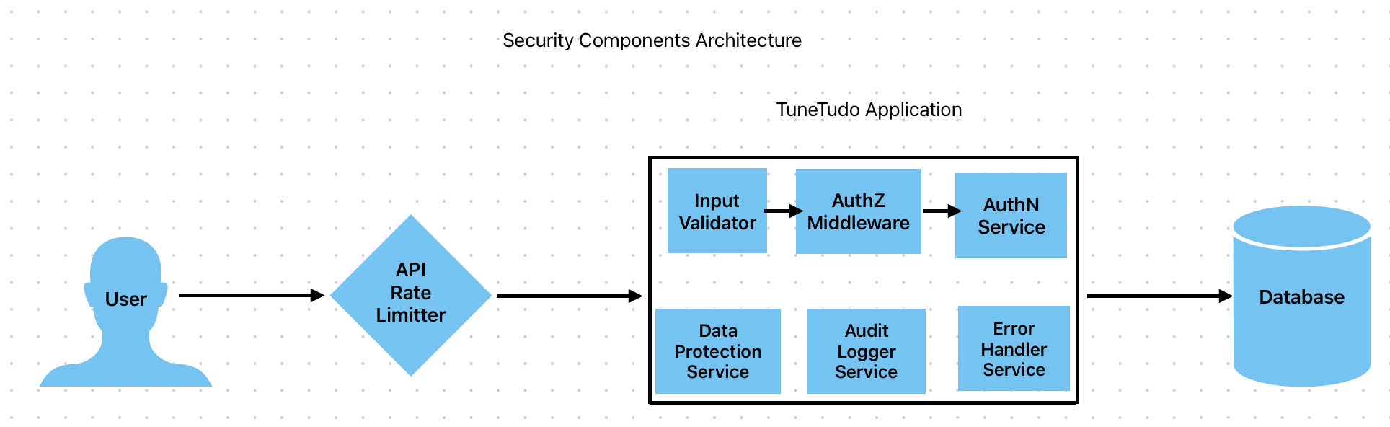

Sub-Components
InputValidator:
- TextValidator, FileValidator, EmailValidator, PasswordValidator, URLValidator
AuthService & DataProtectionService:
- PasswordHasher, TokenGenerator, TokenValidator, RateLimiter

11. Updated Traceability Matrix

Requirement ID | Implementing Component(s) | Key Classes/Modules | Main Test Case | Misuse Case | Security Component
FR-001 | SearchService, Backend API, UI Search | SearchService, song_fts | T-001 | MC-001 | InputValidator, DataProtectionService, XSSProtection
FR-002 | PlaylistService, Playlists UI | Playlist, PlaylistService | T-002 | MC-005, MC-007 | AuthorizationMiddleware (ownership), InputValidator, AuditLogger
FR-003 | PlaylistService, Song listing UI | PlaylistSong, PlaylistService | T-003 | MC-005, MC-007 | AuthorizationMiddleware (ownership), InputValidator, AuditLogger
FR-004 | PlaybackService, Player UI | PlaybackService | T-004 | MC-005, MC-003, MC-007 | AuthorizationMiddleware (ownership), InputValidator, AuditLogger
FR-005 | SearchService / Category APIs, Home UI | Category, SearchService | T-005 | MC-001, MC-004 | InputValidator, DataProtectionService, XSSProtection
FR-006 | PlaylistService, Playlist UI | PlaylistSong, PlaylistService | T-006 | MC-005, MC-003, MC-007 | AuthorizationMiddleware (ownership), InputValidator, AuditLogger
FR-007 | PlaylistService, Playlists UI | PlaylistService | T-007 | MC-005, MC-003, MC-007 | AuthorizationMiddleware (ownership), InputValidator, AuditLogger
FR-008 | UserService, Upload UI, Upload model | Upload, UserService | T-008 | MC-002, MC-006 | InputValidator, RateLimiter
FR-009 | AuthService, Signup UI | User, AuthService | T-009 | MC-005, MC-006,  MC-007 | AuthService, RateLimiter
FR-010 | AuthService, Login UI, PasswordReset | AuthService, PasswordResetToken | T-010 | MC-005 | AuthService, RateLimiter
FR-011 | UserService, Profile UI | User, UserService | T-011 | MC-002,  MC-006 | InputValidator, RateLimiter
FR-012 | AuthService (admin checks), Admin UI | AuthService, AdminService | T-012 | MC-005 | AuthService, RateLimiter
FR-013 | AdminService, Admin UI, MediaService | AdminService, Song | T-013 | MC-002,  MC-006 | InputValidator, RateLimiter
FR-014 | AuthService, Session Management | AuthService | T-014 | MC-009 | SessionSecurityManager

12. References
[1] Accessed: Sep. 28, 2025. [Online]. Available: https://ieeexplore.ieee.org/stamp/stamp.jsp?tp=&arnumber=720574
[2] Accessed: Sep. 28, 2025. [Online]. Available: https://ieeexplore.ieee.org/stamp/stamp.jsp?tp=&arnumber=741934
[3] “System Design · Coding · Behavioral · Machine Learning Interviews,” ByteByteGo. Accessed: Sep. 28, 2025. [Online]. Available: https://bytebytego.com/courses/system-design-interview/scale-from-zero-to-millions-of-users

